Bo Lin

**AEM 685: Midterm # 2**

Due on 11/05/2015

Important: Please work independently. You are allowed to use Matlab, Maple, Mathematica, your notes and books.

**Problem 1**: Minimize the following problem using Genetic algorithm (GA) method.

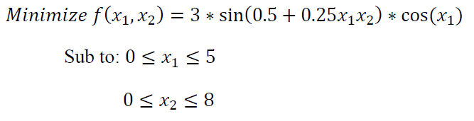

Use the population size equal to two and utilize binary coding for the design variables. Carry out

two iterations of GA using rank based algorithm. You have to show your handwork for two iterations not the program.

(30 points)

**Problem 2:** For the optimization problem,

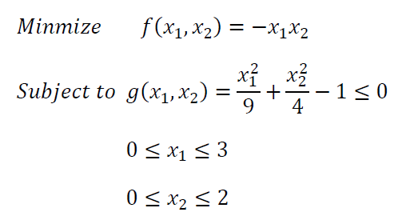

Use two iterations of ‘Method of Feasible Directions’ (page 201 of Vanderplaats) and in Eq.

(6.30), |𝑆| ≤ 1; θj=1. The initial design vector is *[1, 1]*. Show the calculation (handwork) for two

iterations (not the program) (35 points)

**Problem 3:** Solve the optimization problem defined in **Problem 2** using ‘Extended Interior Penalty Function Method’, but you have to use ‘Quadratic Extended Penalty’ approach. We have discussed about this approach in the notes. Start the optimization from the initial design *[2.5, 1.6]*. Show two iterations (handwork) of the optimization.

(35 points)

**Problem 1 Genetic Algorithm**

Initialize:

0≤𝑥1≤5 0≤𝑥2≤8, set 8 bit binary which refer to [0,255]

P255=Pold*[51 0;0 255/8]

Because it is a minimize problem, fitness=C-f*, consider the f range of function, set C=3.

Population size is 2, so initial 2 random parents P1 and P2.

P=[rand(1)*5 rand(1)*8]

P1=[1.1335 6.7533] P2=[3.7690,1.8225]

Fp1=0.8452 Fp2=-1.9386

Iteration 1:

fitness1=2.1548 fitness2=4.9386

for rank based ranking r(i)=2*(ns-i+1)/((ns+1)*ns) r1=2/3 r2=1/3

rand(1,2)=0.7934 0.5623 🡪 choose parent [2,1], that is [P1,P2]

//if randomly chosen [1,1] the algorithm will converge very quickly

randi([1,7])=4 select random string length for mutation

Pdec=[51 215;192 58]; transfer x1 x2 to [0,255]range

Pbin=[00111001 11010111]

[11000000 00111010]

Cmute=[00110000 11001010]

[11001001 00110111]

Cdec_new=[48 218;201 55] Cdec=[0.9415 6.8392;3.9412 1.7255]

Fc1= 1.5154 Fc2=-1.6904 Fp1=0.8452 Fp2=-1.9386

Comparing Fp1 Fp2 Fc1 Fc2, choose c2 p2 as parent for next iteration

Iteration 2

ranked new parent P1=[3.7690,1.8225] P2= [3.9412, 1.7255]

As iteration 1 r1=2/3 r2=1/3

randi([1,7])=3

Pbin=[11000000 00111010]

[11001001 00110111]

Cmute=[11000001 00111111]

[11001000 00110010]

Cdec_new=[193 63;200 50] Cdec=[3.7843 1.9765; 3.9216 1.5686]

fc1= -1.6746 fc2= -1.9043

Comparing Fp1 Fp2 Fc1 Fc2, choose c2 p2 as parent for next iteration

Recent minimum=-1.9386

//Start the algorithm using rank based algorithm may lead to local minimum

**Problem 2 Method of Feasible Directions**

$X_{0}$ =[1 1], $∇F(X_{0})$ =[-1 -1],S=- $∇F(X_{0})$ =[1 1]

g($X_{0}$ +a*S)=0, a=0.6641

$X_{1}$ =[1.6641 1.6641]

Iteration1:

$∇F(X_{1})$ =[-1.6641 -1.6641], $∇g(X_{1})$ =[0.3700 0.8325]

$∇g(X_{1})^{T}S-[∇F\left({X_{1})}^{T}S\right]θ≤0$ $θ=1, |S|≤1$

Maximize: $β$ =- $[∇F\left({X_{1})}^{T}S\right]$

Let S=[a b], function equals to :

Maximize a+b,

Sub to $0≤a^{2}+b^{2}≤1,$ and $∇g(X_{1})^{T}S-[∇F\left({X_{1})}^{T}S\right]θ≤0$

Result: a=0.7753 b= -0.6316 S=[$0.7753-0.6316$]

g($X_{1}$ +a*S)=0, a=1.4342

$X_{2}$ =[2.7529 0.75826]

Iteration 2:

$∇F(X_{2})$ =[-0.7583 -2.7529], $∇g(X_{2})$ =[0.6121 0.3793]

$∇g(X_{1})^{T}S-[∇F\left({X_{1})}^{T}S\right]θ≤0$ $θ=1, |S|≤1$

Maximize: $β$ =- $[∇F\left({X_{1})}^{T}S\right]$

Let S=[a b], function equals to :

Maximize 0.7583*a+2.7529*b

Sub to:1.3704*a+3.1326*b $≤$ 0

Result: a=-0.9162 b=0.4008 S=[$-0.9162 0.4008$]

g($X_{2}$ +a*S)=0, a= 3.0962

$X_{3}$ =[-0.0838 1.9992]

//with $θ$ fixed to 1, it will go away from minimum

**Problem 3 Quadratic Extended Penalty**

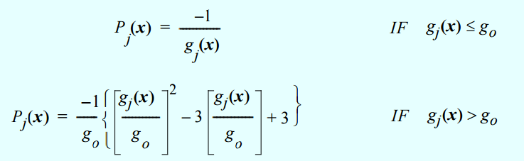

Set g0=-0.1 as the transition point.

$X_{0}$ =[2.5 1.6]

g($X_{0}$)=0.3344 >go

fminsearchΦ(X)=F(x)+r*P(x)

Left figure is the relationship between Φ(X) and X.

Because the parameter $r_{p}$ is 1 in the first iteration

$X_{1}$ locates around the g(x)=0 line.Let X1*=[1.8072 1.6064]

Next iteration $r_{p}$ = $r_{p}*0.3$

g($X_{0}$)= 0.0080>go

Φ(X) didn’t change much …

After $r_{p}$ updated with r*=0.3 for several iterations

The effect of F(x) will shown in Φ(X)

Xn should be located shown in the bottom figure. It can be easily figure out using feasible direction or other approaches.

